SimpleCalendar How-to Guide

# Installing the application

## Downloading the APK

The application can be installed via direct download of the APK (installer), which can be found here [www.simplecalendar.com](http://www.simplecalendar.com)

# Navigating the Application

## Selecting a month

Selecting a month is done using the Action Bar drop down menu, selecting a month will cause the calendar view to update to the new month.

## Changing the year

Changing the year is done sequentially by pressing the Next and Back button on the Action Bar. Changing the year will cause the Calendar view to update.

## Main Menu

To access the main menu, simply tap the icon on the right corner of the action bar. This will display a pop out menu with additional options.

## Returning to the main view

The application utilises an Action Bar. The up icon on the action bar returns the user to the default view, which is the Month View. The back button (Either software or hardware) navigates the user back one screen.

# Event Management

## Adding a New Event

Adding a new event can be done from all views of the application. From the month view, it is accessed via the action bar menu. From the Day view and the list view, it can be accessed by pressing the Menu button on the device and selecting the option from the on-screen menu.

## Adding an alarm/notification

To add an alarm/notification to an event, tick the ‘Alarm box’, this will create a new alarm that has the time set to the Start Time and the same title as the event.

## Viewing all events

All the events can be viewed by selecting the List View from the Action Bar Menu of the Month View. Events will be displayed in Date order, with the closest event being at the top of the list.

## View events for specific date

Selecting a date from the Month View will show the events for that specific date in a List View. The date selected will be visible in the Action Bar at the top.

## Modifying an event

An event can be modified by selecting it from any of the list views. Tapping an event will show it’s details in the Entry Form. Any modifications to the information will be saved after pressing the save button.

Uninstalling the application  
Uninstalling the application can be done in two different ways (steps may vary between android devices and Operating System versions)  
  
Method One:  
Go to the application Drawer by tapping the icon.  
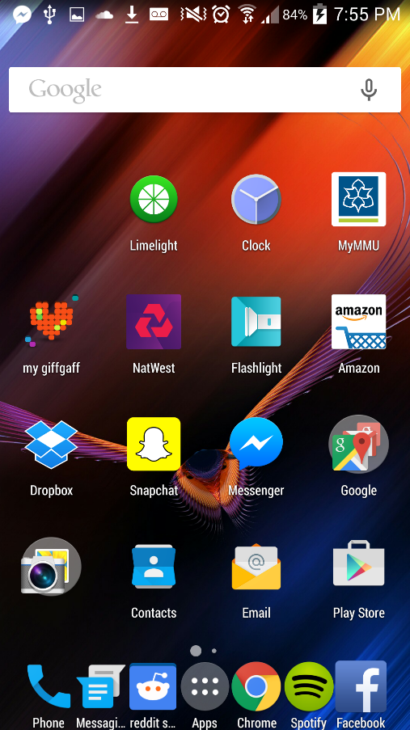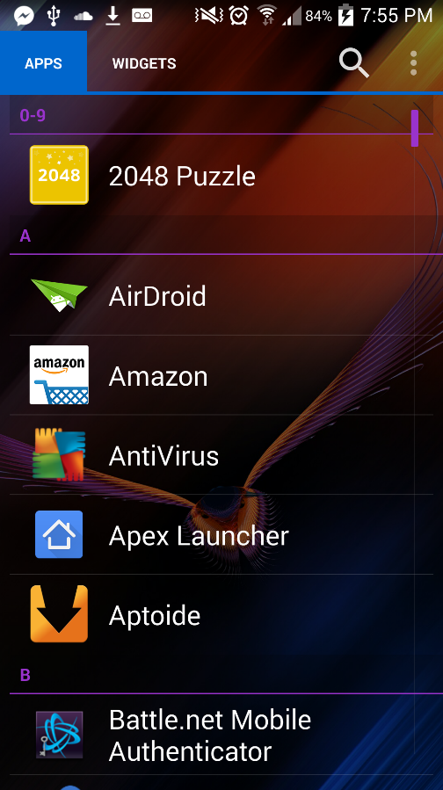

Tap and hold the SimpleCalendar application icon.  
  
Drag the icon to the Bin system labelled Uninstall.  
<Screenshot>

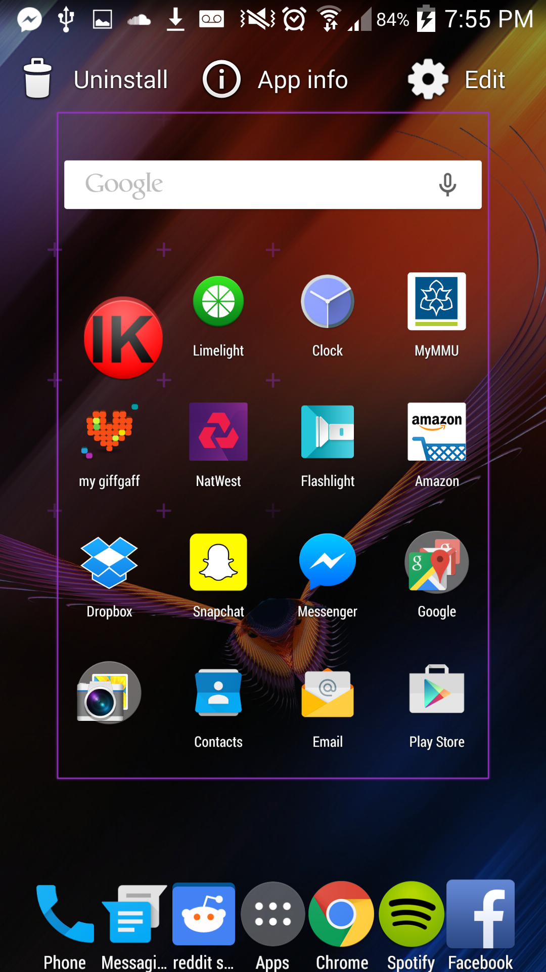

Method Two:  
Go to the System Settings.  
Application Manager  
  
Find and Tap SimpleCalendar  
  
Click Uninstall

